Programming Fundamentals – Lab 03 Tasks

Task 1: GitHub Repository Setup
Create a public GitHub repository named PF-Lab-03. Initialize it with README.md.
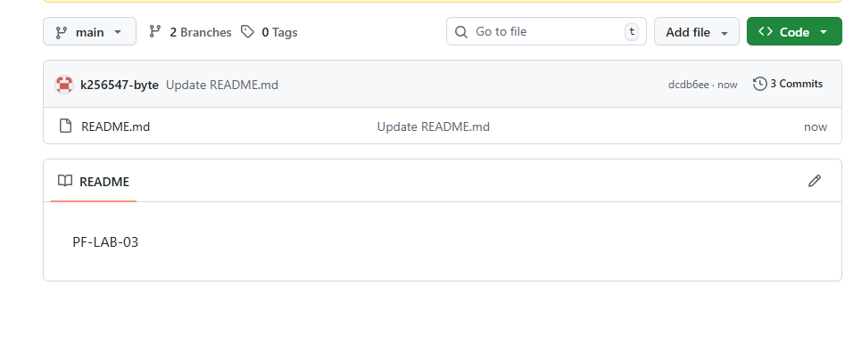

Task 2: README.md Formatting
Update README.md using Markdown:
- Level-1 heading (course title)
- Bold text (name & roll number)
- Unordered list (lab objectives)
- Task list (at least 3 completed tasks)
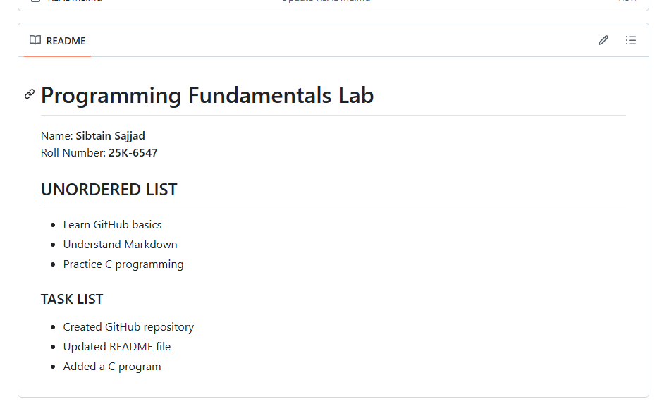

Task 3: Branch Creation
Create and switch to a branch named with your roll number.
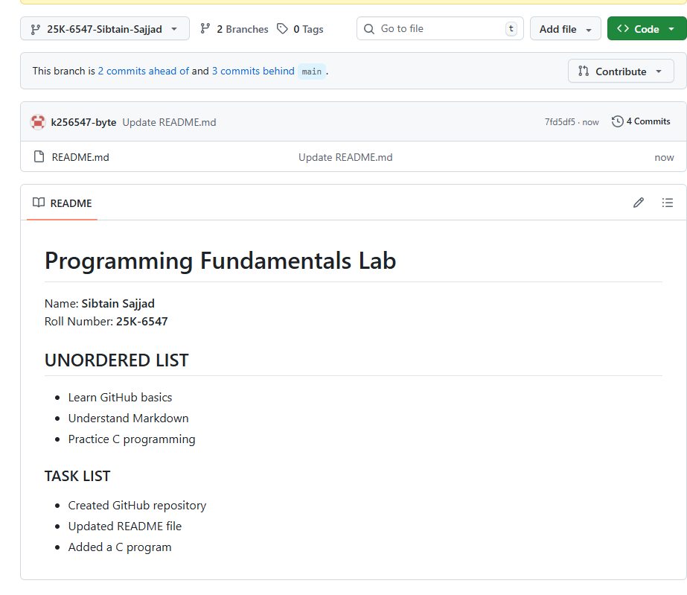

Task 4: Create & Commit a C File
In your roll-number branch, create intro.c, add basic C structure, and commit with a meaningful message.
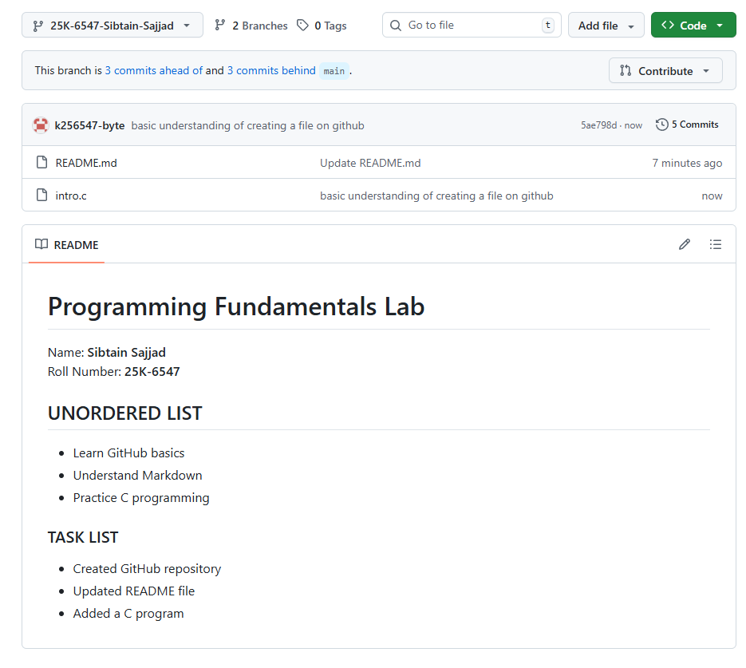

Task 5: Basic Output in C
Write a C program to print:
Welcome to Programming Fundamentals
Spring 2026
Code:
#include <stdio.h>
int main(){
printf("Welcome to Programming Fundamentals Spring 2026");
return 0;
}
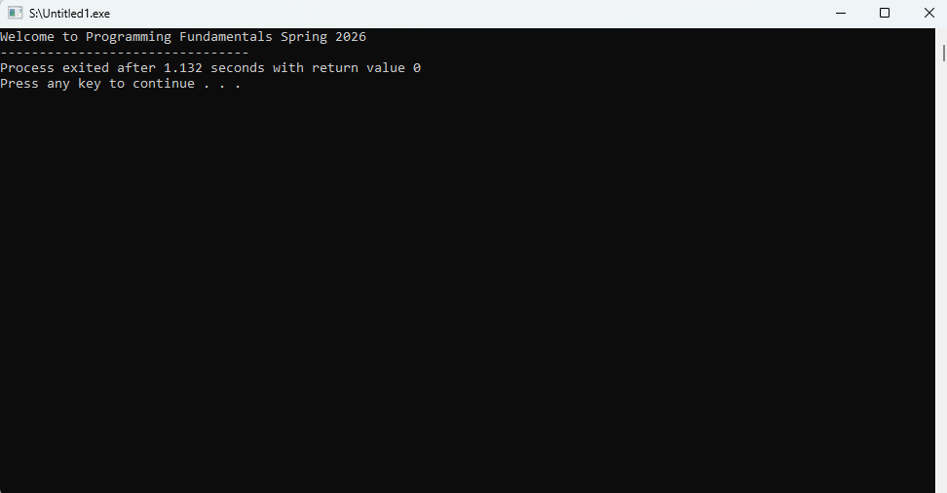

Task 6: Escape Sequences
Write a C program to print name, roll number, and section using \n and \t.
Code:
#include <stdio.h>
int main(){
printf("NAME:\tSibtain Sajjad\n");
printf("Roll number: \t25K-6547\n");
printf("Section:\tBce-1A");
return 0;
}
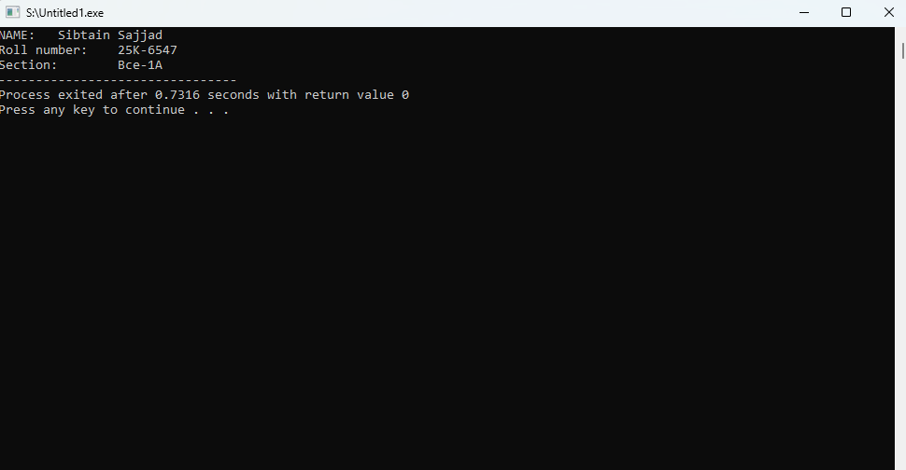

Task 7: Variables & Data Types
Write a C program declaring int, float, double, and char variables and print them using correct format specifiers.
#include <stdio.h>
int main(){
int i = 2;
float x = 2.33;
double y=0.2345;
char a = 'A' ;
printf("integer is = %d\n",i);
printf("floating number is = %f\n",x);
printf("double number is = %f\n",y);
printf("character is = %c\n" ,a);
return 0;
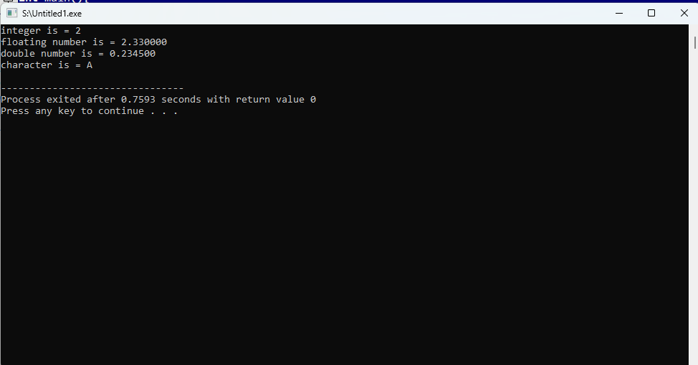

Task 8: User Input
Write a C program that takes an integer, float, and character as input and displays them.
#include <stdio.h>

int main(){
int i ;
float x ;
char y ;
printf("enter integer = ");
scanf("%d", &i);
printf("enter a float number = ");
scanf("%f", &x);
printf("enter a chracter =");
scanf(" %c", &y);

printf("integer is = %d\n",i);
printf("floating number is = %f\n",x);
printf("character is = %c\n" ,y);
return 0;
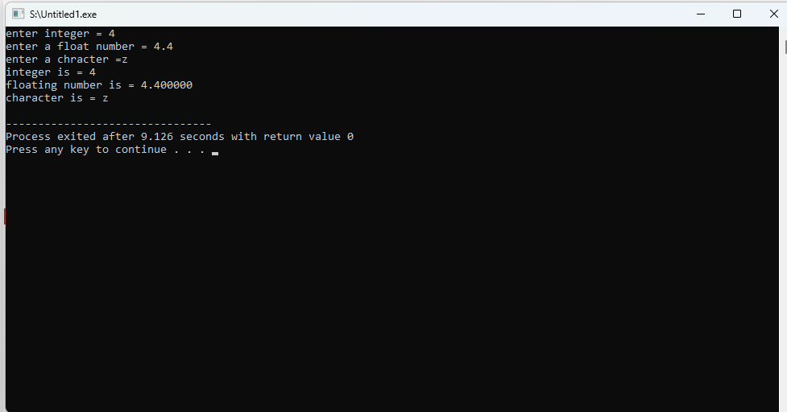

Task 9: Precision Control
Write a C program that takes a double input and prints it with default, 2 decimal, and 5 decimal precision.
#include <stdio.h>

int main(){
double num ;
printf("enter a number = ");
scanf("%lf", &num);
printf("number =%lf\n",num);
printf("number in 2 decimal = %.2f\n", num);
printf("number in 5 decimal = %.5f\n", num);
return 0;
}
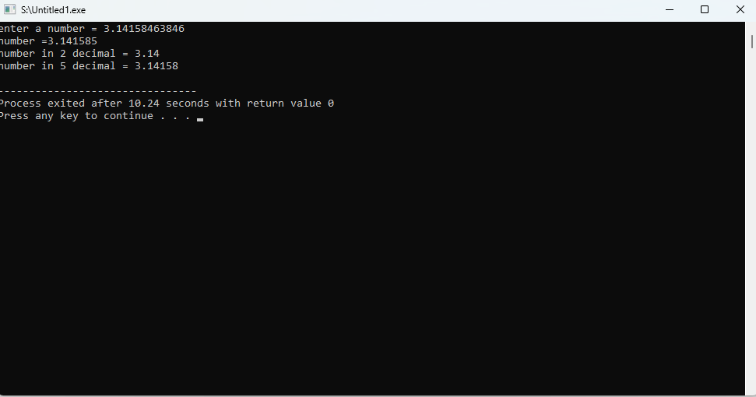

Task 10: Pull Request & Merge
Create a pull request from your roll-number branch to main, merge it, and delete the branch.
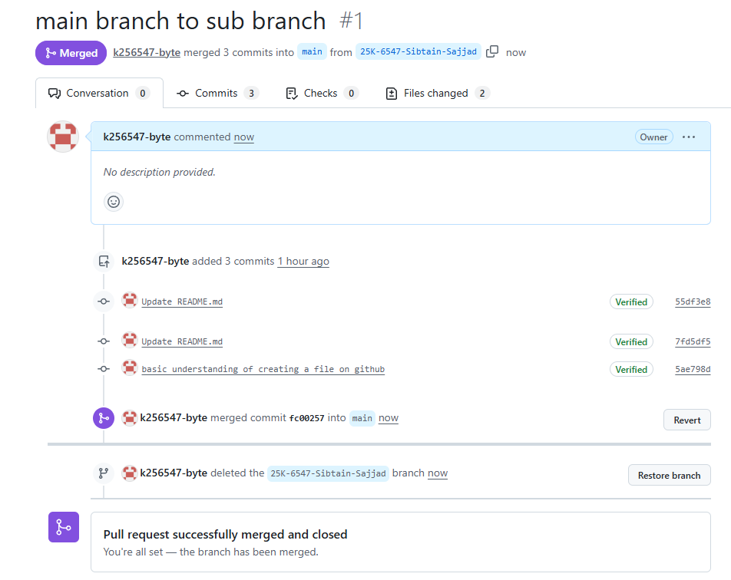
https://github.com/k256547-byte/PF-LAB-03.git

